SUPER S
SUPER CUP 2015
S
NOTICE OF RACE

SUPERCUP SLOVAKIA
8th to 10th of May 2015
TO BE HELD AT
Surfclub Domaša, Holčíkovce, SLOVAKIA
www.surfclub.sk

Organized by:
Akademik Technická Univerzita Košice
in co-operation with the
Slovak windsurfing association and IWA
An International Windsurfing Association sanctioned event including
2015 TECHNO 293 OPEN, 2015 RACEBOARD OPEN


- RULES
  - The event will be governed by the rules as defined in The Racing Rules of Sailing – Windsurfing Competition Rules.
  - The Class Rules of the participating classes.
  - No national prescriptions will apply.
  - If there is conflict between the Notice of Race and the Sailing Instructions (SI’s), the SI’s will take precedence.
  - If there is a conflict between languages the English text will take precedence.

- ADVERTISING
Boards may be required to display advertising chosen and supplied by the organizing authority. ISAF Regulation 20 ‘Advertising Code’ shall apply.

- CLASSES AND DIVISIONS
  - The participating classes and divisions shall be:
3.1.1 Techno 293 – Youth Boy and Girl, Junior Boy and Girl
3.1.2 Raceboard – Open, Women, Masters
  - Age Divisions:
3.2.1 A Techno Junior shall be under 15 years of age and born 2001 or later.
3.2.2 A Techno Youth shall be under 17 years of age and born 1999 or later.
3.2.3 A Master shall be a man over 35 years of age and born 1979 or earlier.
3.2.4 A Grandmaster shall be a man over 45 years of age and born 1969 or earlier.
3.3 A minimum of 5 competitors is required to constitute a division.

- ELIGIBILITY AND ENTRY
  - All entries shall meet the requirements of ISAF Regulation 19-Eligibility Code.
  - Competitors shall be members of a National Class Association, which is a paid up member of the relevant international class association, or of the IWA. Membership formalities can be completed on site.
  - Eligible competitors may enter by completing registration form at the event site.
The following shall be presented upon registration:
- Emergency Contact & Health Information Form – for those under age of 18
- Proof of age
Coaches and team support personnel may register for the event. The following shall be presented upon registration:
- Boat Driving Licence (if applicable)
- Evidence of valid third party insurance

- FEES
  - The required entry fee for competitors 15 euro
  - Entry fees shall be paid in cash at registration

- RACE FORMAT
  - Each event in the Open Championship is “open entry” in the discipline racing, and may include any or all of the formats- course racing, slalom & marathon.
  - Men and women, boys and girls, may race together.
  - Classes shall have separate starts.
  - Classes shall race a maximum 4 races per day, in a maximum 8 race series.

- SCHEDULE
7.1
Fri 8 May 1100 - 2000 Registration & Equipment Inspection
Sat 9 May 0900 – 1100 Registration & Equipment Inspection
Sat 9 May 1100 Opening ceremony
Sat 9 May 1130 First possible start of racing
Sun 10 May 0900 First possible start of racing
Sun 10 May 1500 Last possible warning signal
Sun 10 May 1hour after last race Prize giving

- EQUIPMENT & EQUIPMENT INSPECTION
  - Equipment inspections may be made at any time during the event.
  - Unless otherwise directed by the organizing authority, boards and equipment shall be stored, launched and retrieved from the designated area.

- SAILING INSTRUCTIONS
The sailing instructions (SI’s) will be available upon registration. Any changes to the SI’s shall be approved by the Slovak windsurfing association Representative at the event.

- COURSES
Courses will be as described in the sailing instructions.

- PROTEST COMMITTEE
An ‘Independent Protest Committee’ will be appointed according to WCR 91(a).

- SCORING
12.1 Scoring will be according to the WCR Appendix A, except the discard is as follows
12.2 When fewer than 4 races have been completed, a board’s series score shall be the total of her race scores.
12.3 When 4 to 7 races have been completed, a board’s series score shall be the total of her race scores excluding her worst score.
12.4 When 8 races have been completed, a board’s series score shall be the total of her race scores excluding her two worst scores.
13 SUPPORT BOATS
Support boats shall be registered at the race office. Limited charter may be available and may be applied for using the coach entry form.

14 SAFETY
Every competitor under age of 19 and support boat crewmember shall wear a personal flotation device that shall conform to the minimum standard of ISO 12402-5 (level 50), or as specified in the SI’s.

15 PRIZES
Prizes will be awarded to the first three competitors of each properly constituted class/division.

16 OFFICIAL CEREMONIES
Competitors are requested to attend the event’s social functions; however, the organising authority may refuse entry to those whose standard of attire is not commensurate with the occasion.

17 DISCLAIMER OF LIABILITY
Competitors participate in the event entirely at their own risk. The organising authority or any of their officials or representatives or the sponsors or their officials or representatives will not accept any liability for material damage or personal injury or death sustained in conjunction with or prior to, during or after the event.

18 INSURANCE
Each participating board shall be insured with adequate, and valid, third party liability insurance.

19 RIGHT TO USE NAME AND LIKENESS
In registering for the event, competitors automatically grant to the Organising Authority the right in perpetuity to make, use and show from time to time at their discretion, any motion pictures, still pictures and live, taped or filmed television and other reproduction of them, taken during the period of the event, for the said Event as defined in the Notice of Race and Sailing Instructions in which he/she participates without compensation.

20 FURTHER INFORMATION
Registration will take place at: Surfclub Domaša, Holčíkovce
For further information please contact: Iveta Beránkova Email – ivetka.berankova@gmail.com Tel : +421 905 692 552

ADDITIONAL INFORMATION SHEET
The following information is not part of the rules for the Event.
A ACCOMMODATION
Contact : Iveta Beránková, ivetka.berankova@gmail.com Tel : +421 905 692 552
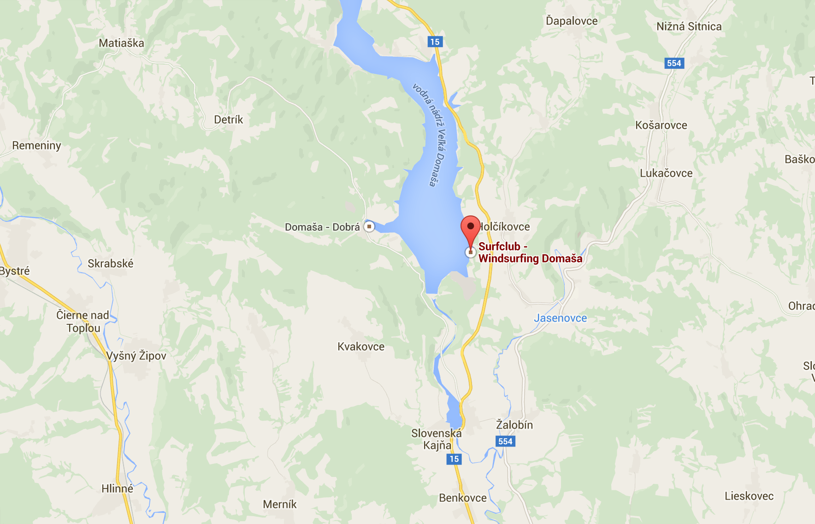

B TRAVEL

